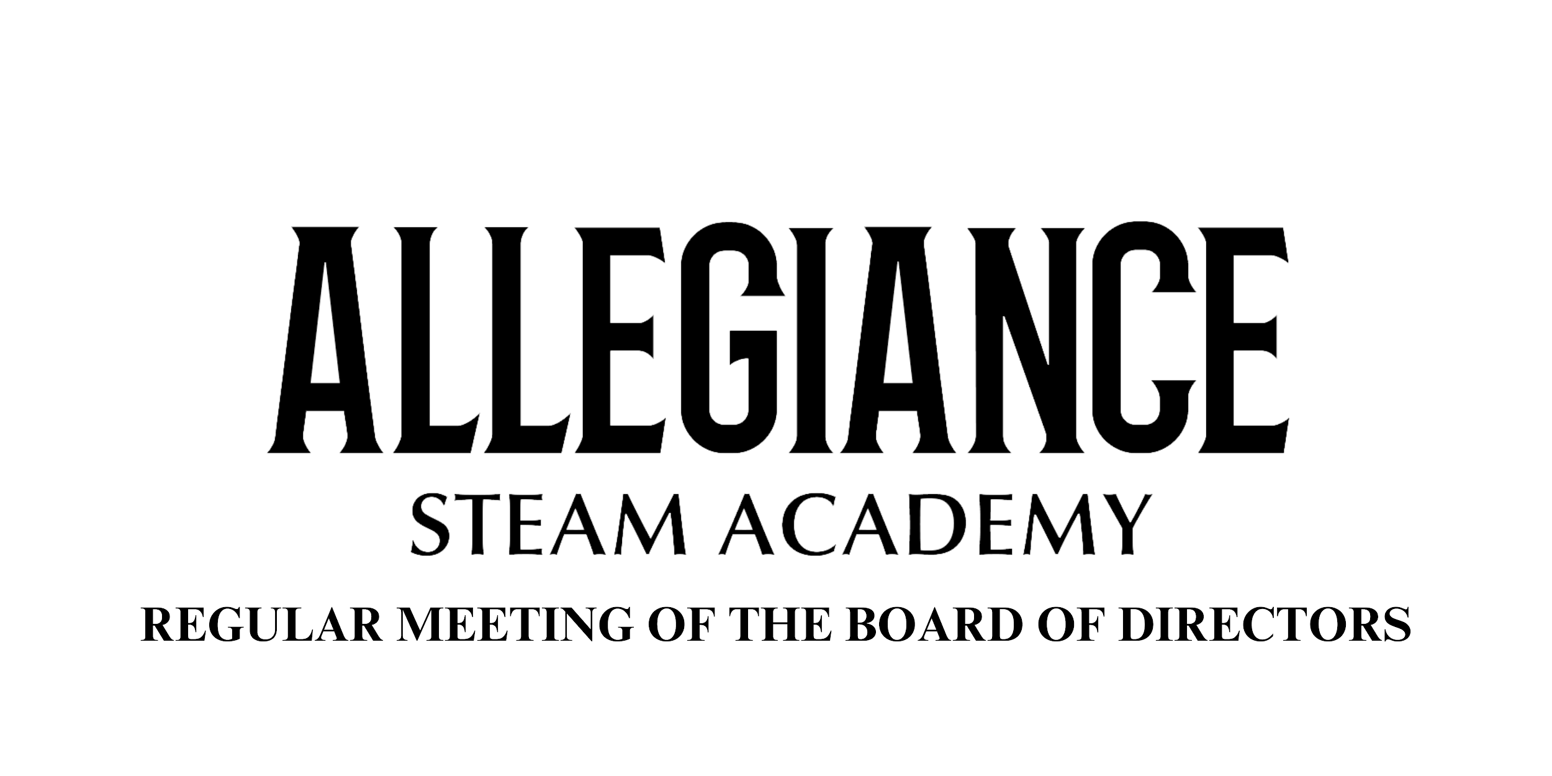

## January 9, 2024

5:00pm

Meeting Location:

5862 C St,

Chino, CA 91710

Streaming Location:

7420 Locust Ave.,

Fontana, CA 92336

View Online

[Zoom Link](https://zoom.us/j/98393372180)

**INSTRUCTIONS FOR PRESENTATIONS TO THE BOARD BY PARENTS AND CITIZENS**

Allegiance STEAM Academy- Thrive charter school (“Allegiance STEAM Academy”), also known as ASA Thrive, is a direct-funded, independent, public charter school operated by the Allegiance STEAM Academy nonprofit public benefit corporation and governed by Allegiance STEAM Academy, Incorporated corporate Board of Directors (“Board”). The purpose of a public meeting of the Board, is to conduct the affairs of Allegiance STEAM Academy in public. We are pleased that you are in attendance and hope you will visit these meetings often. Your participation assures us of continuing community interest in our school.

1. Agendas are available to all audience members at the meeting. Note that the order of business on this agenda may be changed without prior notice. For more information on this agenda, please contact Allegiance at: info@asathrive.org

2. “Request to Speak” forms are available to all audience members who wish to speak on any agenda items or under the general category of “Public Comments.”

3. “Public Comments” are set aside for members of the audience to comment. However, due to public meeting laws, the Board can only listen to your issue, not take action. The public is invited to address the Board regarding items listed on the agenda. Comments on an agenda item will be accepted during consideration of that item, or prior to consideration of the item in the case of a closed session item. Please turn in comment cards to the Board Secretary prior to the item you wish to speak on. These presentations are limited to three (3) minutes.

4. In compliance with the Americans with Disabilities Act (ADA) and upon request, Allegiance STEAM Academy may furnish reasonable auxiliary aids and services to qualified individuals with disabilities. Individuals who require appropriate alternative modification of the agenda in order to participate in Board meetings are invited to contact Allegiance STEAM Academy.

## I.Preliminary

**A. Call to Order The meeting was called to order by the Board Chair at _____5:10pm______.**

**B. Roll Call Present Absent**

* Troy Stevens, President ___X___ ________
* Marcilyn Jones, Secretary_______ ____X (Absent)__
* Samantha Odo, Treasurer___X___ ________
* Shantay Thompson, Member __X____ ________
* Shehzad Bhojani, Member ___X___ ________

**C. Approval of Agenda for the Regular Board Meeting for January 9, 2024**

It is recommended that the Board of Directors approve the Agenda for Regular Board Meeting for January 9, 2024.

Motion: ____Sam_____ Second: ___Shantay____ Aye: __4___ Nay: ____ Abstain: ____

## 

## II.OpenSession

**A. Pledge of Allegiance**

**B. Items Scheduled for Information**

1. Bellwether Presentation *-* [Stephanie Spangler](mailto:stephanie.spangler@bellwether.org)

*The Board requested more parent research be done. They would also like to have the info be delivered by admin to parents. Troy stated that he will email* [Stephanie Spangler](mailto:stephanie.spangler@bellwether.org)*with additional questions.*

1. Principal’s Report - ASA Chino

*Happy New Year and we are officially through half the school year. Winter break was nice to rest and decompress. Lazp & I wrapped up our goals with the leadership team. How can we level up and support the staff? Mid Year Evaluations were completed before the break. After break we asked the teachers what is one thing they are grateful for? Optiva presented the words that were shared. SLC’s are coming soon. We reviewed our previous surveys and looked at the feedback. Enrichment was the biggest concern of why they aren't involved. We will be including them this year. Individual grading was another issue. Progress reports will be going home early. Service learning project will be another blood drive. The PACK was unable to attend. A friendship gram will be happening as well. We have been doing alot of reflection. Enrichment will also be providing a monthly newsletter in the WWU.*

1. Principal’s Report - ASA Fontana

*Happy New Year! So happy to see enrichments being involved with SLC’s. Evaluations are under way to complete this month. Great Wolf Way challenge, 1000 Pawsitive Slips in under 50 days. Reward will be APEX wolf visit. SLC’s are coming and have been the focus of the PLN’s. Fontana will also host a bloodrive. 228 student enrollment by the end of the week. Askin fontana for 6 additional classrooms in order to grow next year.*

1. PACK Report - Chino

*No Report / Not Present Color Run coming up next month.*

*PACK Report - Fontana - filing for 5013C has been received, 22nd next meeting.*

1. SSC Report - Chino

*Ms. Hamilton - 5th grade teacher and member of SSC. Highest attendance gets the wolf in their classroom. Discussed minimum days being moved to Wednesday’s. Voted during our meeting to move minimum days to Wednesday.*

1. CEO’s [Report](https://drive.google.com/drive/folders/1G5MHHg_QL3y0w6cPfj_vODxKfDsnDmdU?usp=sharing)

*Tomorrow the governor will be announcing the budget update at 10:00am. Sebastian showed a graph to show the gap in ADA and attendance since COVID. Fontana with a smaller student body, it doesn’t take much to lower the number. Attendance matters and we need to incentivize the students' attendance. IS is continuing in both schools. Sebastian showed a District comparison with other schools around the same size. We have realized that we need to grow. We have added a HR staff member to help with this growth. Next year we would like to add an additional staff member to the District Office. Volunteer numbers are 371 in Chino and 4 in Fontana.*

1. Board Study Session - [Updates](https://docs.google.com/document/d/1042W4bpj-1t058sQRE46KX5UXbFN4DMob2EZrANEHAM/edit?usp=sharing)

*Sebastian presented a document to show the updates from the study session.*

*Also provided, was the updates per site. Sebastian also provided a video that*

*showed a recap video of the training that had taken place. Troy would like to see*

*the results of how things are being implemented and if it's working. Valenta*

*stated that they will be making data driven decisions to see if the trainings are*

*beneficial.*

1. Request for Proposal - [Before/After School Care Providers](https://docs.google.com/document/d/1C4dNW8FB3xHb-Xu9eX7eDA7Pn1nfoAoITq35TYd_OnE/edit?usp=drive_link)

*Sebastian presented the fact that we need to bring on other options/proposals for our families. We will be evaluating the Boys and Girls Club in Fontana for the remainder of the year.*

**C. Student Celebrations**

*Students presented with Mrs. Piyawadhanachi on the Math Candy Project and a*

*3D Bedroom project that they worked on in collaboration with Mr. G, Mrs. Riley as*

*well. Leadership - Friendship grams. 8th grade is planning a Starry Night Dance*

*on Jan 26th. Rachel’s Closet will be recycling uniforms and making them*

*available to students.*

## 

## III.PublicAnnouncementforReasonforClosedSessions

**A. Public Comments on Closed Session Items**

*Comments related to closed session items shall be limited to no more than three minutes. If you wish to speak on an item that will be discussed in a closed session, please turn in a comment card to the Board Secretary.*

*No Comments*

**B. Closed Session - For Discussion/Possible Action**

*Anticipated Litigation (Gov. Code section 54956.9(d)(2).): ([one matter])*

*Closed Session began at 6:41pm.*

*Open Session began at 7:35 pm.*

## 

## IV.OpenSession

**A. Report from Closed Session**

*Nothing to be reported out.*

**B. Public Comments - Items not on the Agenda**

No individual presentations shall be for more than three (3) minutes. Ordinarily, Board members will not respond to presentations and no action can be taken. However, the Board may give direction to staff following a presentation.

*No Comments*

**C. Items Scheduled for Consent:**

1. [Minutes](https://docs.google.com/document/d/1o9XoBNOqMpNjkjdF4NWL5D1ks9lFPBnUE6NhkTDfw6U/edit?usp=drive_link) for the Regular Meeting of the Board of Directors, December 4, 2023
2. [Minutes](https://docs.google.com/document/d/1yKEoqnVfhIb7OoMBLKwXVhxosfm34V9HV_-WoXz-btM/edit?usp=sharing) for the Special Meeting of the Board of Directors, December 12, 2023
3. Check Register for November, 2023

Motion: ___Shantay______ Second: ___Sam_____ Aye: __4___ Nay: ____ Abstain: ____

**D. Items Scheduled for Discussion/Action:**

1. **Revised FY23 Budget - ASA Chino**

It is recommended the Board of Directors:

Approve and adopt the FY23 [Budget](https://drive.google.com/file/d/1hX0hgAMmhptVj69V_CKc8Y-vHlQ91nOf/view?usp=drive_link) - ASA Chino

Motion: ___Sam_____ Second: ____Troy______ Aye: __4___ Nay: ____ Abstain: ____

**2. Revised FY23 Budget - ASA Fontana**It is recommended the Board of Directors:

Approve and adopt the FY23 [Budget](https://drive.google.com/file/d/1hX0hgAMmhptVj69V_CKc8Y-vHlQ91nOf/view?usp=drive_link) - ASA Fontana

Motion: ____Shehzad______ Second: ___Sam______ Aye: __4___ Nay: ____ Abstain: ____

**E. Communications**

1. **Comments from CEO**

*Sebastian - Working with our bank for the Suite Funds to see the best options for ASA. This month we are finishing compliance / audit (P1) and will probably need a special board meeting at the end of the month for approval. We have a new format for the board agenda with Smore to allow easier access.*

1. **Comments from the Board of Directors**

*Shehzad - Happy New Year and looking forward to a great year.*

*Sam - Happy New Year and thank you to our presenters.*

*Shantay - Happy New Year! The presenters were amazing and really enjoyed the*

*projects.*

*Troy - Happy New Year and thank you for the presenters. Liked the feedback that*

*has been provided tonight. Excited to see what Chino does to Level Up and*

*Fontana to Fontana Forward. Kids were so excited to come back to the campus*

*after the break.*

**F. Adjournment**

It is recommended the Board of Directors:

Adjourn the Regular Meeting of the Board of Directors for January 9, 2024 @ 7:46 pm

Motion: ______Sam_______ Second: __Shantay______ Aye: __4___ Nay: ____ Abstain: ____