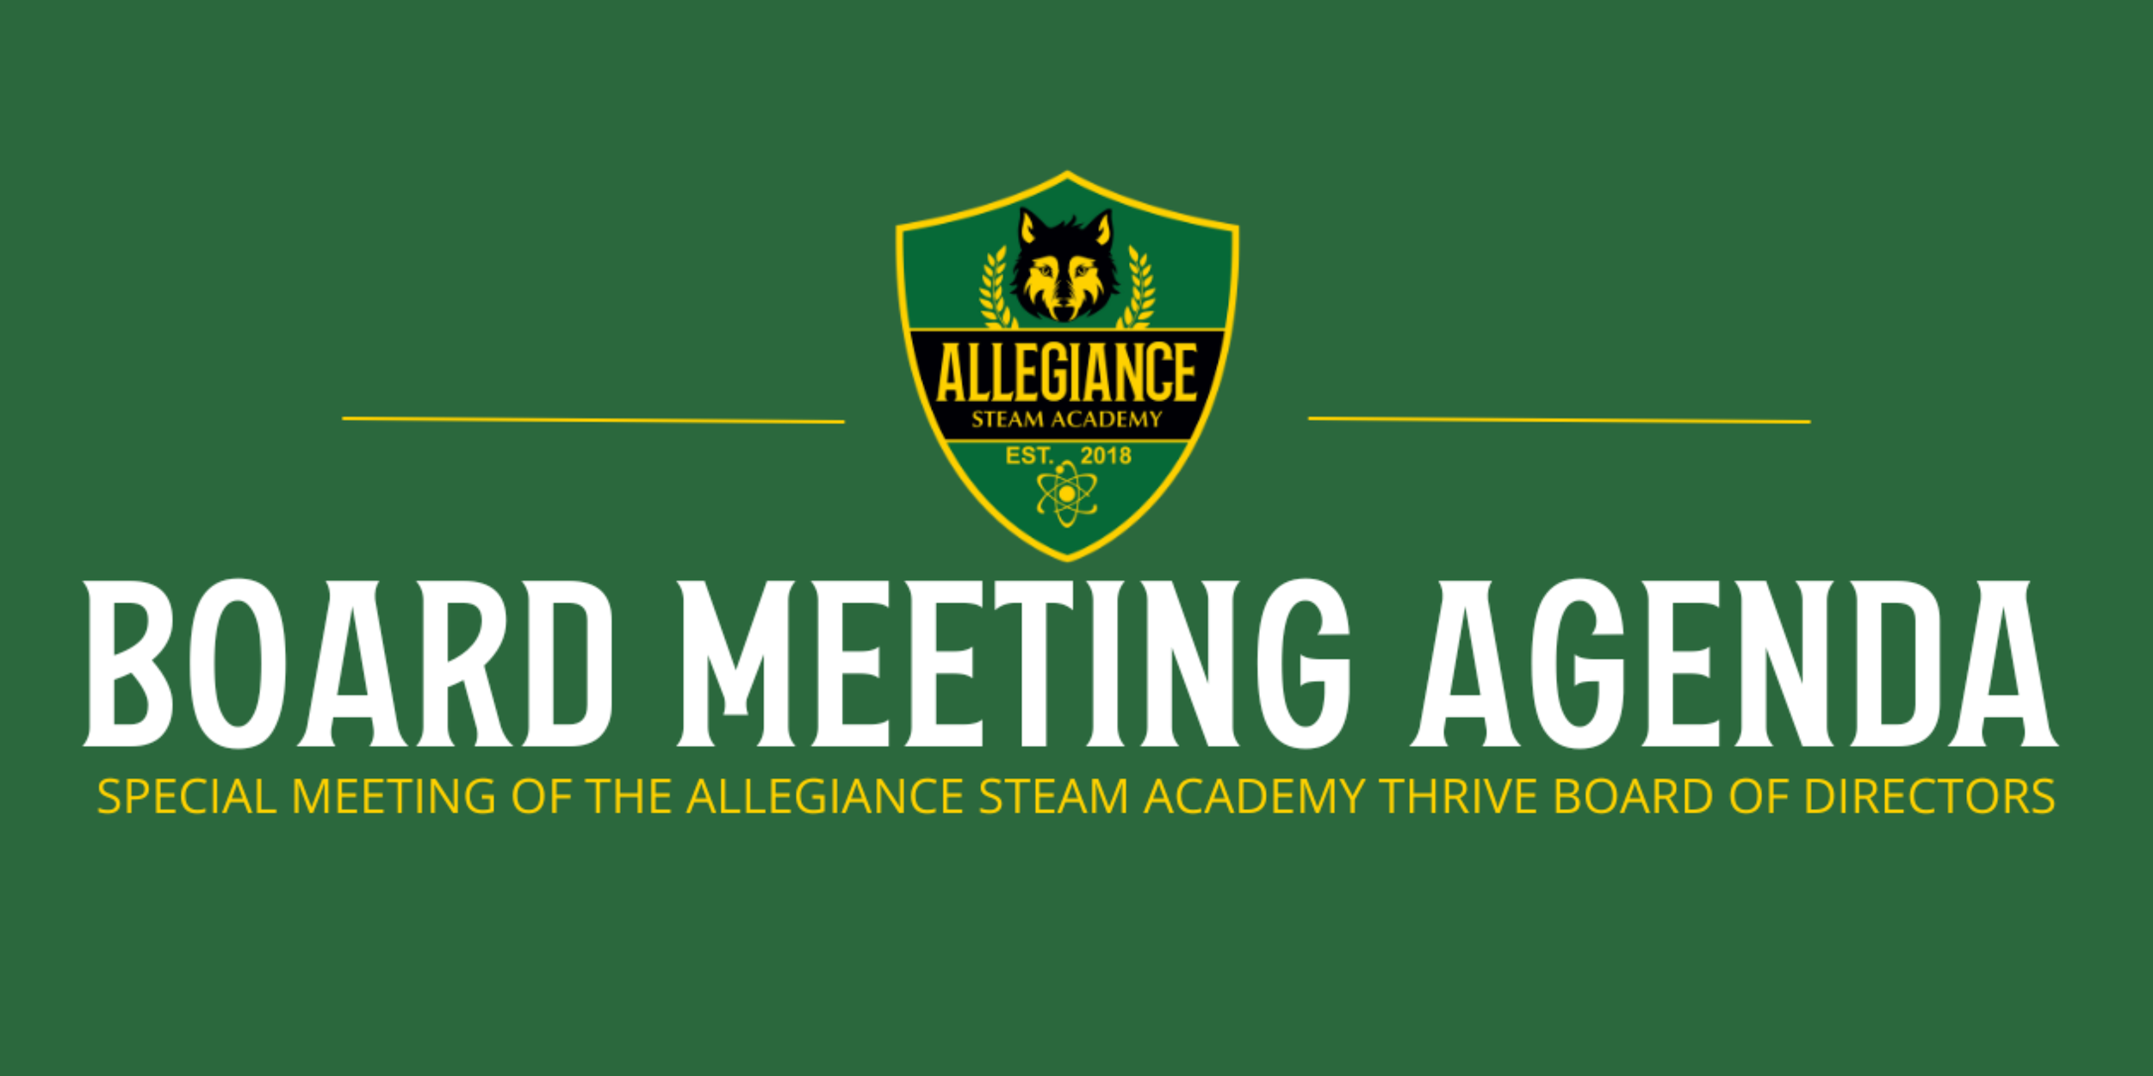

## Tuesday, January 30, 2024

***5:30 pm***

***Meeting Location:***

*5862 C St.,*

*Chino, CA 91710*

***Streaming Location:***

*7420 Locust Ave.,*

*Fontana, CA 92336*

[**ZOOM LINK**](https://zoom.us/j/97393232923)

## AGENDA

**INSTRUCTIONS FOR PRESENTATIONS TO THE BOARD BY PARENTS AND CITIZENS**

Allegiance STEAM Academy- Thrive charter school (“Allegiance STEAM Academy”), also known as ASA Thrive, is a direct-funded, independent, public charter school operated by the Allegiance STEAM Academy nonprofit public benefit corporation and governed by Allegiance STEAM Academy, Incorporated corporate Board of Directors (“Board”). The purpose of a public meeting of the Board, is to conduct the affairs of Allegiance STEAM Academy in public. We are pleased that you are in attendance and hope you will visit these meetings often. Your participation assures us of continuing community interest in our school.

1. Agendas are available to all audience members at the meeting. Note that the order of business on this agenda may be changed without prior notice. For more information on this agenda, please contact Allegiance at: info@asathrive.org

2. “Request to Speak” forms are available to all audience members who wish to speak on any agenda items or under the general category of “Public Comments.”

3. “Public Comments” are set aside for members of the audience to comment. However, due to public meeting laws, the Board can only listen to your issue, not take action. The public is invited to address the Board regarding items listed on the agenda. Comments on an agenda item will be accepted during consideration of that item, or prior to consideration of the item in the case of a closed session item. Please turn in comment cards to the Board Secretary prior to the item you wish to speak on. These presentations are limited to three (3) minutes.

4. In compliance with the Americans with Disabilities Act (ADA) and upon request, Allegiance STEAM Academy may furnish reasonable auxiliary aids and services to qualified individuals with disabilities. Individuals who require appropriate alternative modification of the agenda in order to participate in Board meetings are invited to contact Allegiance STEAM Academy

## I.Preliminary

**A. Call to Order**

The meeting was called to order by the Board Chair at ___6:17PM______.

**B. Roll Call (Present/Absent) Present Not Present**

* Troy Stevens, Chair _______ ___X____
* Marcilyn Jones, Secretary ___X____ _______
* Samantha Odo, Treasurer ___X____ _______
* Shehzad Bhojani, Member _______ ___X____
* Shantay Thompson, Member ___X____ _______

**C. Approval of Agenda for the Special Board Meeting for January 30, 2024**

It is recommended that the Board of Directors approve the Agenda for Special Board

Meeting for January 30, 2024.

.

Motion: __Shantay_____ Second: ___Marcy____ Aye: __Passes 3-0___ Nay: ____ Abstain:

## 

## II.OpenSession

**A. Pledge of Allegiance**

**B. Public Comments- Items on the Agenda**

No individual presentations shall be for more than three (3) minutes. For Special

meetings of the Board, public comments are limited to agenda items only. Ordinarily,

Board members will not respond to presentations and no action can be taken. However,

the Board may give direction to staff following a presentation.

*No Comments*

**C. Items Scheduled for Discussion/Action**

*1.*[*Memorandum of Understanding:*](https://docs.google.com/document/d/1OYv8oeRTP6XgjNmqM1OjghMCNCGS9pjv/edit?usp=sharing&ouid=113574451212345674724&rtpof=true&sd=true) *Boys and Girls Club of Fontana and Allegiance STEAM Academy*

* It is recommended the Board of Directors approve and adopt the Memorandum of Understanding: Boys and Girls Club of Fontana and Allegiance STEAM Academy.

***Cognetta stated that this will be funded through grants until the end of the school year. After School program will only be after school. FUSD also uses Boys & Girls Club as one of their providers. ASA provides the insurance for Boys & Girls Club.***

Motion: ___Macry___ Second: ___Sam____ Aye: __Passes 3-0___ Nay: ____ Abstain:

*2.* [*Consolidated Application:*](https://drive.google.com/file/d/14etmyOrzoyQF2RyL3VVO7-LgWbQ6WtOC/view?usp=sharing) *ASA Chino*

* It is recommended the Board of Directors: approve and adopt the Consolidated Application for ASA Chino

Motion: ____Marcy__ Second: ___Shantay__ Aye: _Passes 3-0____ Nay: ____ Abstain: _

*3.* [*School Accountability Report Card*](https://sarconline.org/public/summary/36676780137547/2022-2023) *- ASA Chino*

* It is recommended the Board of Directors approve and adopt the School Accountability Report Card for ASA Chino

Motion: ___Sam____ Second: __Marcy___ Aye: __Passes 3-0___ Nay: ____ Abstain: ____

*4.* [*School Accountability Report Card*](https://sarconline.org/public/print/36677100141952/2022-2023) *- ASA Fontana*

* It is recommended the Board of Directors approve and adopt the School Accountability Report Card for ASA Fontana

***The Board has requested Cognetta to notify them once the information is received by FUSD. Also to find out why the communication is not consistent. Board has asked that we change the Principal name to Cognetta.***

Motion: _Shantay___ Second: __Marcy____ Aye: _____ Nay: _3-0___ Abstain: ____

***\*New motion to replace principles name to Sebastian Cognetta:***

***Motion: ___Sam____ Second: __Marcy___ Aye: __Passes 3-0___ Nay: ____ Abstain: ____***

**D. COMMUNICATIONS**

1. Comments from the CEO

***Cognetta - Would like to keep the next Board Meeting the same for next Monday. Last week Chino celebrated 100 day of school and Fontana will celebrate tomorrow.***

2. Comments from the Board of Directors

***Sam - Shoutout to flag football. We are the only school who is co-ed.***

***Marcy - Have a great night.***

***Shantay - No Comments***

**E. ADJOURNMENT**

1. It is recommended the Board of Directors adjourn the Special Meeting of the Board of Directors for January 30, 2024 @ 6:45PM.

Motion: _____Sam______ Second: __Macry_______ Aye: _____ Nay: ____ Abstain: ____